​[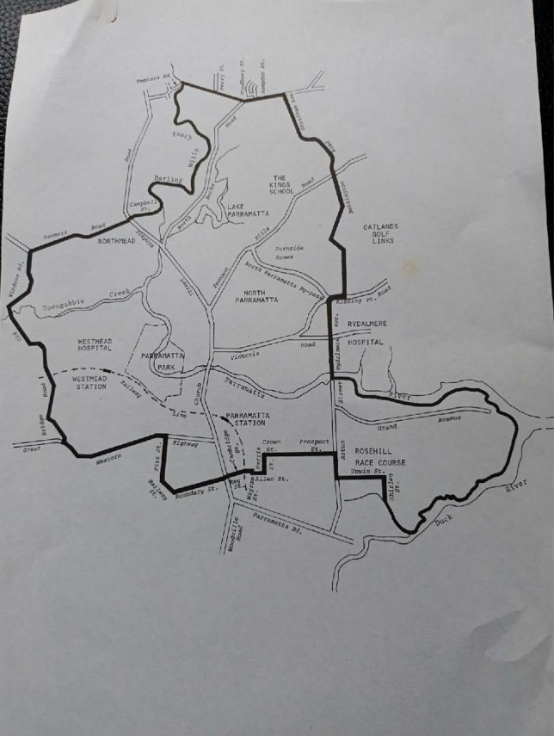](https://my-tlcp.com/ckfinder/3/userfilesimages/Capture(1).PNG)​​